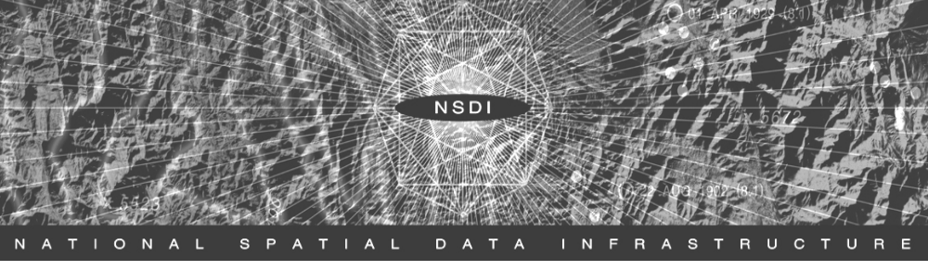

2006

National Spatial Data Infrastructure

Cooperative Agreements Program

Grant Opportunities

The National Geospatial Programs Office (NGPO) of the US Geological Survey announces the 2006 NSDI Cooperative Agreements Program (CAP). The CAP grant provides seed funds to assist organizations in implementing the components of the National Spatial Data Infrastructure (NSDI). Eligible activities include participating in the NSDI Clearinghouse Network, Geospatial One-Stop portal, National Map collaborative programs, web service interoperability, geospatial organizational collaboration, metadata documentation and harvesting, and framework theme standards. The CAP is open to all U.S. organizations.

The Federal Geographic Data Committee (FGDC) sponsors the CAP to promote the technologies, standards, best practices and organizational collaboration vital to data integration, partnerships for data investment and speedy delivery of geospatial products to support government. The FGDC consists of 19 Federal agencies in collaboration with State, local and Tribal governments, academic, non-profit and the private organizations. The FGDC Secretariat is hosted by the NGPO.

Application information, funding categories and materials describing the CAP program and past year’s projects can be found on-line at the FGDC website. Application materials can be accessed on-line at the FGDC website and Grants.gov. For more information on the CAP contact David Painter at (703) 648-5513 or dpainter@fgdc.gov.
The CAP program announcement and application materials will be accessible through the FGDC website: www.fgdc.gov or directly by query at grants.gov beginning on or about December 1, 2005.
Announcement closes February 1, 2006.

www.fgdc.gov or www.grants.gov

Funding Categories for the 2006 NSDI Cooperative Agreements Program
Program Announcement Number 05HQPA0007
Catalog of Federal Domestic Assistance (CDFA) No. 15.809

Approximately $1,150,000 is available under this year's program.

Category 1: Metadata Trainer and Outreach Assistance provides assistance to organizations with NSDI expertise knowledge and experience in assisting other organizations with the training and implementation of metadata, clearinghouse or web mapping services. Maximum award $25,000 (50% in-kind match), approximately 5 projects

Category 2: Framework Client Development projects will develop software clients for Framework Data Services. These services will exploit online Framework Data to support operational needs of an application community. Software will be distributed freely through an established community as an extension to an existing geographic information system or as an open-source software solution that can be integrated into specific decision- support or data management processes. Maximum award $75,000 (50% in-kind match), approximately 3 projects

Category 3: Fifty States Initiative: Strategic and Business Plan Development in Support of the NSDI Future Directions Fifty States Initiative. Projects will develop and implement statewide strategic and business plans that will facilitate the coordination of programs, policies, technologies, and resources that enable the coordination, collection, documentation, discovery, distribution, exchange and maintenance of geospatial information in support of the NSDI and the objectives of the Fifty States Initiative Action Plan. Maximum award $50,000 (50% in-kind match), approximately 10 projects

Category4: Canadian-US Spatial Data Infrastructure Project will support one collaborative project between organizations in the U.S. and Canada that have an interest in creating, maintaining, and sharing geospatial data over a common geography. This is a collaborative funding opportunity sponsored by GeoConnections Canada and the FGDC. U.S lead award up to $75,000; Canadian lead award up to $100,000 CDN, (100% in-kind match).

Category 5: Geographic Information Integration & Analysis category seeks to develop sustainable partnerships to integrate, maintain and provide access to current geospatial data and to develop the infrastructure needed to integrate these data and make them available through geospatial programs of the NGPO. The goal of this category is to assist organizations and consortia to work together with the NGPO to develop and provide access to geospatial information that serves community needs. . Maximum award $50,000 (100% in-kind match), approximately 5 projects.

www.fgdc.gov or www.grants.gov


