FGDC Leads Development of Integrated Geospatial Capabilities

The explosive growth of technologies that produce and leverage geospatial information has created both enormous opportunities and considerable challenges for the federal government. More than a decade ago, the nation’s leaders recognized that effective use of this vital information tool would require close coordination among the many agencies involved in its development.

And so, the Federal Geographic Data Committee (FGDC) was created as the interagency coordinating body of the National Spatial Data Infrastructure (NSDI). FGDC was established by Executive Order in 1994 to assemble the technology, policies, standards, and human resources necessary to acquire, process, store, distribute and improve utilization of geospatial data for a variety of users nationwide. FGDC is taking on more of a leadership role within the government enterprise as the importance of geospatial capabilities to improve efficiency and effectiveness of government is recognized.

Office of Management and Budget (OMB) Circular A-16 (revised August 2002) incorporates the Executive Order and authorizes the FGDC to govern the coordinated development, use, sharing, and dissemination of geospatial data nationally. With the launch of the Geospatial Line of Business, the development of the Geospatial Profile of the Federal Enterprise Architecture, and the growth in federal membership and collaborating partners in 2006, the FGDC is continuing to seek a more effective and inclusive governance structure.

The FGDC:

    - Brings together Federal agencies and public interest organizations to meet the broadest array of needs. Agency-led working groups and subcommittees address challenges day to day.
    - Is governed by a Steering Committee that sets high-level strategic direction. A Coordination Group advises on the FGDC’s day-to-day business, which is carried out by the FGDC Secretariat located at the U.S. Geological Survey.
    - Is one of three initiatives under the USGS National Geospatial Program Office (NGPO) – along with Geospatial One-Stop (focused on discovery and access) and The National Map, which centers its efforts on integrated, certified base mapping content.
    - Includes committees, working groups and coordinating partners that initiate and support activities crucial to developing the NSDI:

  - Developing and establishing the National Geospatial Data Clearinghouse on the Internet.
  - Developing and implementing standards.
  - Creating a national digital geospatial data framework of basic, recurring data themes.
  - Promoting collaborative relationships for geospatial data among non-Federal partners.
  - Developing policies and processes to better harmonize collective action.

Key FGDC accomplishments include:

- Solidifying the six basic building blocks of the NSDI: metadata, clearinghouse, standards, framework, geospatial data, and partnerships.
- Establishing a grant program—the NSDI Cooperative Agreements Program (CAP) – to provide merit-based seed money for collaborative NSDI resource-sharing projects across the public and private sectors.
- Helping establish the Global Spatial Data Infrastructure (GSDI) to harmonize international development of spatial data infrastructures.
- Working with the Federal Chief Information Officers (CIO) Council, in concert with key collaborating partners, have developed the Geospatial Profile of the Federal Enterprise Architecture (FEA).
- Taking a leading role in the efforts to launch the Geospatial Line of Business
- Working toward establishing a new inclusive NSDI governance model to ensure input and commitment from all stakeholders

For more information, visit the FGDC’s Web site at www.fgdc.gov.

2006 FGDC Highlights

During 2006, the FGDC engaged in a wide range of activities to meet its mission. Key initiatives are highlighted below:

Development of a Geospatial Profile

Various levels of government today possess geospatial capabilities, but at different levels of progress and consistency. Interoperability requires greater documentation of those capabilities, along with systematic implementation.

The Federal Geographic Data Committee and the Federal Chief Information Officers Council, in concert with non-federal partners, have developed the Geospatial Profile of the Federal Enterprise Architecture (FEA) to help all levels of government properly integrate their geospatial information. FEA profiles already have been developed for Security and Privacy and for Records Management.

The Geospatial Profile highlights geospatial patterns in each of the FEA reference models and points agency architects to best practices in building interoperable geospatial capabilities to serve local, state and federal needs. It guides each agency’s progress in all five FEA Reference Models to reflect geospatial capabilities – Business, Performance, Technology, Data, and Service Components.
Geospatial Line of Business

The Office of Management and Budget (OMB) is building on resources collected for the Geospatial Profile to identify a crosscutting Geospatial Line of Business initiative. The LoB’s goals include:
- Improving agency mission performance;
- Reducing costs – government-wide – via consolidation and standardization, and;
- Simplifing service delivery for both customer facing and back-office services.

There are three phases in the realization of this Line of Business initiative –

- Analysis – Development of a vision, goals and objectives, national business architecture, and a baseline inventory of data and services.
- Definition – Development of a public Request for Information (RFI) and its analysis, a concept of operations, a solution requirements document, target business architectures, the business case, and a transition strategy.
- Operation – Guidance for agencies in meeting policy objectives, on integrating the LoB into target business architectures, and facilitating the implementation of LoB common solutions.

These first two phases were nearing conclusion at the end of 2006.

The LoB initiative seeks to formalize budgetary and business alignment practices that optimize the government’s overall geospatial investment. This may include enhanced governance, procurement guidance, service-level agreement templates for geospatial services, and identification of government-operated or contracted common solution service providers for specific functions.

Another likely outcome is formalization of the roles, responsibilities, and performance metrics for geospatial information stewards.

In its operational phase the LoB will have a continuing requirement for a small project management office, coordinated with FGDC and OMB, to maintain high awareness and visibility of the planning and reporting requirements as well as a forum for the logistical agreements on establishing government-wide geospatial capabilities.

Together the Geospatial Profile and the LoB draw a roadmap for NSDI implementation via use of business-driven requirements, enterprise architecture, and budgetary techniques. Whereas geospatial technology and capabilities still require some context and logical architecture, the realization of an effective NSDI depends most on social and organizational commitments to establish and maintain robust capabilities and agreements that support mission requirements transcending the needs of any one agency, company, or organization.
Cooperative Agreements Program (CAP)

For 12 years, the FGDC has used the CAP to help the geospatial data community implement components of the NSDI. The program – which is open to federal, state, local and tribal governments, as well as academia and commercial and non-profit organizations – has provided small seed grants to for sustainable NSDI implementation. The program emphasizes partnerships, collaboration, and the leveraging of geospatial resources to achieve its goals.

CAP awards have played a substantial role in promoting and disseminating the tenets of the NSDI to thousands of practitioners. To date, CAP awards have created collaborations at all levels of government, developed an understanding of geospatial information in organizations and disciplines new to the NSDI, provided seed money to enable geospatial organizations to participate in the national effort to implement the NSDI, promoted the development of standardized metadata in hundreds of organizations, and funded numerous implementations of OGC Web Mapping Services and Web Feature Services.

Key program achievements during 2006 included:

- Conducting three Train-the-Trainer Workshops by grant recipients: USGS's National Biological Information Infrastructure (NBII), the NOAA Coastal Services Center, and the Center for International Earth Science Information Network (CEISIN) at Columbia University. In all, 34 metadata trainers were prepared to train larger groups.
- Creating training opportunities for more than 330 people within city, county and tribal government entities – including public health and emergency response organizations – by the NBII, the Merriam Powell Research Center at the University at Northern Arizona, the University of Idaho, the University of Indiana, Columbia University and the government of Westchester County, NY.
- Saving more than $8.5 million in staff time through the Minnesota Geographic Data Clearinghouse.
- Configuring and deploying Web Feature Services (WFS) by Vermont, Rhode Island, Minnesota, North Carolina and the Center for International Earth Science Information Network (Columbia University) to support NSDI Framework themes, including Governmental Units, Hydrography, and Transportation.
- Providing seed funding to Wisconsin to promote the advantages of a shared spatial infrastructure within that state.
- Helping the Tennessee Valley Authority provide access to its Aerial Photography Index via an OGC Web Map Service.
- Supporting South Carolina’s establishment of a user-friendly geospatial portal.
- Helping the California Geographic Information Association bring together national, state, regional and local organizations to draft a comprehensive regionally-relevant, nationally consistent framework data plan. This provides the foundation for a California GIS Council data plan and will be used to promote the FGDC’s “Fifty States Initiative”.
- Completing 11 high-resolution hydrologic units, which were added to the National Hydrology Database, under the leadership of the Wisconsin Department of Natural Resources.
- Helping the University of Oklahoma incorporate local data into the development of high-quality street centerline data.

Under the 2006 CAP, there were 25 ongoing projects – totaling $1.2 million – addressing five areas:

- The Fifty States Initiative, designed to accelerate statewide coordination activities that advance the National Spatial Data Infrastructure.
- Projects that enable organizations with NSDI expertise, knowledge and experience to assist other organizations with the training and implementation of metadata, clearinghouse, and/or Web mapping services.
- Framework Client Development projects that are developing software clients for Framework Data Services. These services will exploit online Framework Data to support operational needs of an application community.
- Through joint funding by GeoConnections Canada and the FGDC, a Spatial Data Infrastructure project that will map the spread of infectious diseases across the Maine/New Brunswick border.
- Partnerships to integrate, maintain and provide access to current geospatial data and to develop infrastructure that integrates these data and makes them available through geospatial programs of the NGPO.

Over the years, desired CAP outcomes have been modified to meet evolving NSDI requirements. For 2007, CAP is refocusing some projects, as follows:

- Awards still will be given to projects under the Fifty States Initiative, and for framework client development and for geographic data integration.
- The metadata trainer and outreach assistance category has been expanded to include all FGDC-endorsed standards.
- To support the Geospatial Line of Business, a new category was added. The new Geo-Enabled Federal Businesses Initiative will communicate the value of incorporating geospatial approaches into business processes to federal business managers.

The 2007 budget of $1.2 million will fund up to 26 projects.

For more information about the CAP see http://www.fgdc.gov/grants.

The Fifty States Initiative – Building a Strong NSDI

Building a viable NSDI to serve the needs of all levels of government, as well as the private sector, requires a solid foundation that is strategic, deliberate and assembled in discrete, manageable units. The Fifty States Initiative – a joint effort launched in 2005 by the FGDC and the National States Geographic Information Council (NSGIC) – is such a “bottom-up” approach to NSDI-building. Particularly targeted to meet state and local needs, it nurtures development of healthy, statewide GIS coordination councils (not just state agencies) and promotes collaborative opportunities for advancing the NSDI – including standards-based data development.

The accompanying graphic shows the five phases of creating a strategic plan and managing the process. A feedback loop ensures that progress toward achieving plan goals is monitored and appropriate strategy adjustments are made to account for changing conditions.

INSERT GRAPHIC

Key developments during 2006 included:

- The FGDC’s announcement of a new grant category under CAP, designed to support implementation of the Fifty States Initiative. The FGDC secretariat provided $500,000 in such grants during FY 2006 to advance the initiative. EPA provided an additional $50,000. Eleven awards were made to develop and implement statewide strategic and business plans that will advance NSDI activities. These individual plans will reflect the current “condition” in each of these states as well as their unique business needs, laws and political landscapes.

- States working on current NSDI CAP grants met in October 2006 during NSGIC’s Annual Conference in Little Rock, AR. Each state provided an update on its progress to date and discussed issues of concern when implementing a strategic or business plan.

Under the Fifty States Initiative, everyone “has a place at the table” and is welcome to participate. This is an evolutionary process that will take several years to fully implement.

International Program – Making Progress in Many Areas

During 2006, a three-way agreement was signed among the FGDC, the Joint Research Board representing INSPIRE (the equivalent of the FGDC for the European Union) and GeoConnections (Canada’s complement to the FGDC).
The agreement seeks to improve sharing opportunities in areas ranging from portal philosophies to enterprise architecture and Global Earth Observations, and to develop cross-border projects similar to the one established by the FGDC and GeoConnections for the CAP Grant Program. All three organizations plan to collaborate on data sharing and research opportunities.

Douglas Nebert received the Premio “Carlos A. Carvallo Yanez” Award from the Pan American Institute for Geography and History (PAIGH) as the editor and chief of the GSDI Cookbook. Version 2, published in January 2004, draws on authors from around the world. It is the highly regarded reference manual on how to build a National Spatial Data Infrastructure.

The Group on Earth Observations (GEO) moved into its implementation stage in 2006. GEO includes 66 member countries, the European Commission, and 43 participating organizations working together to establish a Global Earth Observation System of Systems. GEOSS will build on and add value to existing Earth-observation systems by coordinating their efforts, addressing critical gaps, supporting their interoperability, sharing information, reaching a common understanding of user requirements, and improving delivery of information to users.

Working closely with the Global Spatial Data Infrastructure (GSDI) Association, the Ninth GSDI meeting is in the final planning stages. Scheduled for early November 2006 in Santiago, Chile the meeting will feature more than 200 proposed papers, 53 technical sessions, 8 workshops, 6 technical committee meetings; 8 regional and technical roundtables, 2 plenary sessions; about 50 posters, and related business meetings. In addition the GSDI-9 has arranged with 6 other sister organizations to conduct related technical and business meetings in conjunction with the conference in Santiago. They are;
  - United Nations Geographic Information Working Group (UNGIWG)
  - International Steering Committee for Global Map (ISCGM),
  - Pan American Institute for Geography and History (PAIGH)
  - Regional and National Spatial Data Infrastructures in the Americas (PCIDEA)
  - FRAME (an AID sponsored environmental project)
  - Earth Science Congress for Latin America
The Santiago session is the eighth GSDI meeting since 1994 and exemplifies the growing worldwide interest in using and sharing geospatial data to address a wide range of issues and challenges that cross international borders.

The FGDC Metadata Program – Coordination and Collaboration with USGS Geospatial Liaisons

The FGDC Metadata Program promotes and coordinates geospatial metadata activities among FGDC member agencies in support of the National Spatial Data Infrastructure. Metadata establishes a mechanism for coordination, development, use, sharing, and dissemination of geospatial metadata among FGDC member agencies, state, local, academic, and Tribal agencies and institutions.
The FGDC Metadata Program benefits from sister programs and partners and coordinates with the Cooperative Agreements Program, CAP, the NSDI Training Project, the FGDC Standards Working Group, and the FGDC Training and Education Team.

In June 2006, the FGDC Metadata Program coordinated metadata training with Kari Craun, Chief of USGS Central Region’s Partnership Office, to provide an introductory metadata tutorial and a Business Case for Metadata workshop. This tutorial and workshop can be made available to the other regional Partnership Offices. Other FGDC metadata training activities include:

- Training programs for the Gulf Coast region, under an agreement with Texas A & M’s Gulf Coast Studies and Cooperative Ecosystem System Unit.
- Development of Framework Standard training materials through an agreement with the Wyoming Geographic Science Center at the University of Wyoming. This is a multi-module, downloadable, and on-line materials development project.

A New Governance Model – Furthering the Development of the NSDI

Resulting from the work of the Future Directions Initiative and the Governance Action Team, the FGDC has recommended the establishment of The National Geospatial Advisory Committee under the Federal Advisory Committee Act (FACA). The Department of the Interior is the sponsoring agency. The purpose of the committee is for non-federal stakeholders to provide advice and recommendations to the FGDC related to the management of national geospatial programs, the development of the NSDI and the implementation of OMB Circular A-16. Drafting of a charter and establishment of the Committee membership are identified next steps for 2007.
Geospatial One-Stop Access to the NSDI Clearinghouse Network

In 2005 the Geospatial One-Stop portal, geodata.gov, became the official means to access the metadata resources managed in the NSDI Clearinghouse Network. Metadata held by government (federal, state, local) and by commercial, tribal, university, and non-profit organizations are published through the Clearinghouse Network to geodata.gov.

In 2006, more than 100,000 individual metadata records were available via geodata.gov – a 30 percent increase from the previous year. Key federal metadata holdings are shown in Figure A. Additional metadata collections are being discovered and added to the Network on a regular basis. Additional resources will be included in the future to reflect the ‘starter metadata’ from the NSGIC statewide data inventory tool and an inventory of previously undocumented local Web mapping services described by the Naval Research Laboratory (NRL) in its GIDB portal system.
Figure A – Metadata records in Geospatial One-Stop Portal by federal agency (as of October 2006)

The number of registered collections within the NSDI Clearinghouse Network continues to grow, as shown in Figure B. An effort to integrate the NSDI registry of metadata servers using Z39.50 with the geodata.gov portal list of services is underway. This will yield a consolidated set of registered services such as catalogues, map services, and feature data services to be made public in FY 2007.
Figure B

Figure C shows the number and relative percentage of registered metadata collections, primarily supporting the Z39.50 search and retrieval protocol worldwide. The number of collections, or “nodes” continues to grow gradually both nationally and internationally.
Figure C

Geospatial Marketplace

The Geospatial One-Stop Partnership Marketplace is an innovative capability of the geodata.gov portal that allows organizations to publish their interest or intent in collecting geospatial data. The publication of these requirements and plans presents an opportunity for collaboration in the collection or funding of data by potential partners over a common geography. By the end of 2006, the marketplace had grown to include approximately 3,000 planned data acquisition records (abbreviated FGDC metadata records with a bounding box of interest).

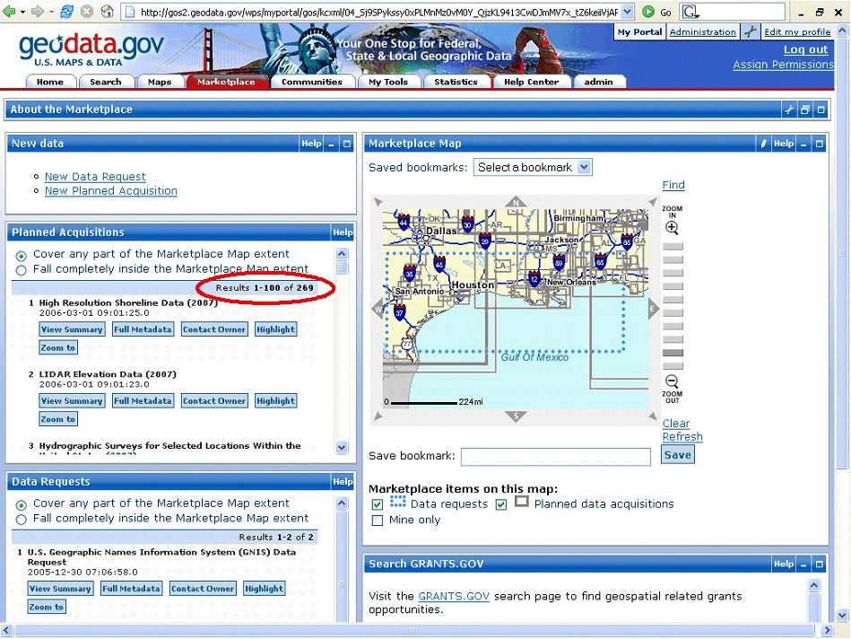

Figure D – Geospatial Marketplace in geodata.gov

Standards Activities – Facilitating the Development and Sharing of Geospatial Data.

Standards development is a critical factor in facilitating the development, sharing, and use of geospatial data. The FGDC develops geospatial data standards for implementing the NSDI, in consultation and cooperation with state, local, and tribal governments, the private sector and academic community, and, to the extent feasible, the international community.

The FGDC standards activity had several notable accomplishments in 2006:
- The FGDC Standards Working Group approved a proposal to develop a Wetlands Mapping Standard.
- The International Committee for Information Technology Standards (INCITS) Technical Committee L1 approved Project 1574-D, Information technology - Geographic Information Framework Data Content Standards (AKA Framework Data Standard), for further processing to become an American National Standard. The draft Framework Data Standard was created to enable data exchange for seven fundamental geospatial themes of critical importance to the development of the NSDI.
- The FGDC endorsed the Digital Cartographic Standard for Geologic Map Symbolization.

- A systematic review of the FGDC standards program of work was started in 2006. Reviews of FGDC standards that have been endorsed five years or more were conducted and recommendations were developed for further action.

NSDI Training Materials Under Development

An array of NSDI Training Materials is on the way, growing out of preliminary workshops held during 2006. Modules are being developed for Enterprise Architecture, Web Services, Spatial Data Infrastructure, Partnerships, Metadata, CAP, Geodata.gov, Homeland Support, and Standards Integration.

A draft curriculum has been designed and inventories are being updated to reflect relevant training materials using a standardized database. Each module will have its own lesson plan.

The final products will become part of the FGDC’s online training system. Memorandums of Agreement with multi-organizational partnerships nationwide offer expanded training and education on the NSDI. Federal agencies engaged in the training program include USGS/EROS, NOAA Coastal Services Center, NPS, FWS, DHS/FEMA, USDA/FS and EPA.

